**Website Home Page:** [**https://www.sdsmt.edu/index.html**](https://www.sdsmt.edu/index.html)

**Research Labs & Centers**

Feature these four:

1. Arbegast Materials and Processing and Joining Lab (AMP)

<https://www.sdsmt.edu/research-innovation/research-facilities/labs-and-centers/amp.html>

Photo: <https://www.flickr.com/photos/sdsmt/51637639787/in/album-72157720083507699/>

Description: Creating advanced metals processing technologies to bolster manufacturing industries.

1. Center for Solid-State Electric Power Storage (CEPS)

<https://www.greenceps.com/>

Description: Developing eco-friendly, safe, and economically feasible solid-state energy storage technology.

1. CNAM Bio

<https://www.cnambiocenter.org/>

Photo: <https://www.flickr.com/photos/sdsmt/53235246827/in/photolist-2p7dxMG-2p7dxN8-2p7jvkb-2p7dxMr-2p7dyce-2p7kvcA-2p7dyed-2p7hY31-2p7jRX9-2p7jRPP-2p7jvEV-2p7jvFS-2p7hYdg-2p7jRrV-2p7jvJc-2p7jRVa-2p7dytm-2p7hXyF-2p7dxZR-2p7dyb2-2p7dxZW-2p7jvCk-2p7dyaq-2p7dyh4-2p7jS3K-2p7kvEE-2p7hY6Y-2p7dyhE>

Description: Solving bioprocessing challenges with biopolymers and specialty chemicals from renewable resources.

1. Center for Sustainable Solutions

The link on the current website is not working.

Found here: 

Description: Finding solutions for water quality, emerging contaminants, agriculture, carbon capture, biofuels, and more.

**Research & Innovation Section**

**Homepage:** <https://www.sdsmt.edu/research-innovation/index.html>

This information needs to be included on the page (before Subscribe to The Forefront)

**Advanced Materials & Manufacturing:** Creating high-performance materials and efficient manufacturing processes.

**Deep Underground Science & Engineering:** Exploring physics, geology, and engineering below the Earth’s surface.

**Critical & Sustainable Resources:** Managing vital natural resources for modern technologies.

**Smart & Resilient Cyber-Infrastructure:** Designing systems that ensure security, efficiency, and resilience.

**Data Science & Numerical Modeling:** Using data for creative problem-solving solutions.

 Is it possible to add research news stories to this page?

Text BoxText BoxText Box

Related Links at bottom of the page:

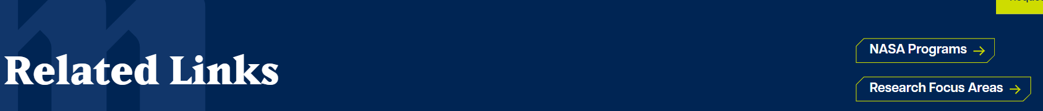

NASA Programs link

* The page should be titled NASA Programs instead of Research.
* Remove this info from the page:

South Dakota Mines faculty, research staff, and students work on projects that advance scientific knowledge and contribute to economic development. These projects address needs critical to our state and nation and are supported by numerous funding agencies and industry partners.

* Advanced Materials & Manufacturing
* Data Science & Numerical Modeling
* Smart & Resilient Cyberinfrastructure
* Critical & Sustainable Resources
* Deep Underground Science & Engineering

Research Focus Areas link – remove this link

Add a link for Research Policies and link to the Policy Manual - <https://www.sdsmt.edu/about/policies-and-compliance/policy-manual.html>

This page can be removed because it is a repeat of information found on the R&I homepage. <https://www.sdsmt.edu/research-innovation/research/index.html>

When I click on the Section Menu from this page: <https://www.sdsmt.edu/research-innovation/research-facilities/index.html>

Remove Rich and Trudy Wells Veterans Resource Center

**Research Facilities Page**

<https://www.sdsmt.edu/research-innovation/research-facilities/index.html>

Do not need a Section Menu on this page as the items listed there (Labs and Centers and Off Campus Labs) are included on this page.

Laboratories should be aligned with Centers (it shifts right on the computer but looks ok on my phone)

On this list: Mining Hub – needs to link to wherever that page is housed. This is the Ektron page: <https://ektron-prod94.sdsmt.edu/Academics/Mining-Hub/>

Let’s work on making the Laboratories section sexier – its ok for now but needs some visual love.

**Innovation & Entrepreneurship Page**

<https://www.sdsmt.edu/research-innovation/innovation-entrepreneurship/index.html>

Does “Invention Services include” have to be in this large of a font?

The way the list appears with the arrows makes it seem like these should each be a link. The only ones that should link are i-Corps and Entrepreneurs-in-Residence

**I-Corps Page**

<https://www.sdsmt.edu/research-innovation/innovation-entrepreneurship/icorps.html>

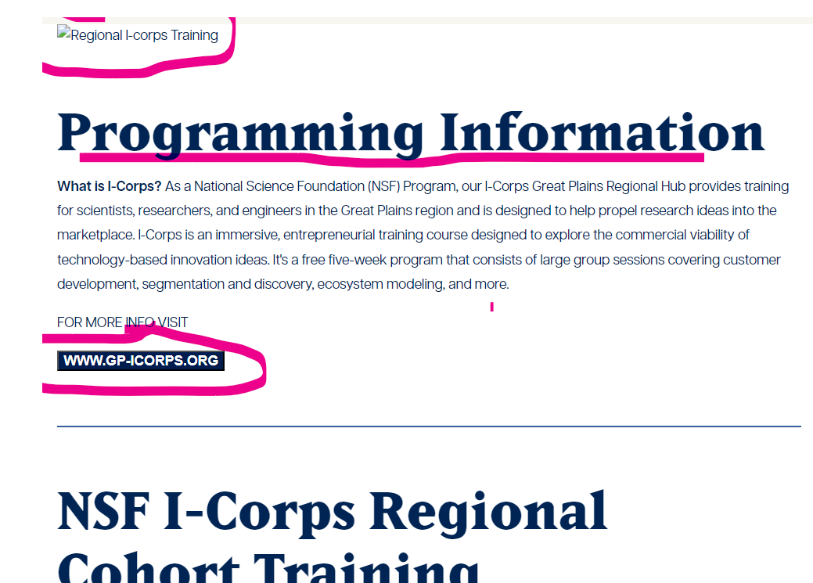

* Looks like there should be a photo at the top.
* Change “Programming Information” to What is I-Corps
* In the paragraph under the heading, remove What is I-Corps
* The link to [www.gp-icorps.org](http://www.gp-icorps.org) does not work

Section Menu

Remove all but Startups & Affiliates

**Startups & Affiliates Page**

<https://www.sdsmt.edu/research-innovation/innovation-entrepreneurship/startups-affiliates.html>

Add this intro to the top of the page above the listing of companies: Join a legacy of success at Mines, where several thriving businesses have launched from within our university. Be part of an ecosystem that not only fosters groundbreaking ideas but also transforms them into successful commercial ventures, propelling innovation and entrepreneurship to new heights.

Company Listing Layout:

Remove the slider in the middle and center Astra Nanotech

**Add a new page under Innovation & Entrepreneurship**

**License Our Tech** - [**www.sdsmt.edu/Research-Innovation/Innovation-Entrepreneurship/License-Our-Tech**](http://www.sdsmt.edu/Research-Innovation/Innovation-Entrepreneurship/License-Our-Tech)

South Dakota Mines is at the forefront of a broad spectrum of technological advancements. These innovative ideas are poised to address the complex challenges faced by industry, society, and our nation. Here are some of the cutting-edge technological developments emerging from our campus.

* Advanced Manufacturing
* Advanced Engineering Materials
* Advanced Computing
* Artificial Intelligence
* Biomanufacturing
* Biotechnologies
* Clean Energy Generation and Storage
* Data Privacy, Data Security, and Cybersecurity
* Highly Automated, Autonomous, and Uncrewed Systems, and Robotics
* Neutrinos and Dark Matter
* Quantum Materials

Ask about licensing these technologies.

Beth Lambeth, AVP of Research – Innovation & Entrepreneurship

(605) 394-5168

Economic.Development@sdsmt.edu

**Add a new page under Innovation & Entrepreneurship**

**Student Innovation Cycle Page – New (**[www.sdsmt.edu/Innovation-Entrepreneurship/Student-Resources](http://www.sdsmt.edu/Innovation-Entrepreneurship/Student-Resources))

**Student Innovation Cycle**

Innovation at Mines goes beyond labs and centers; it's everywhere. You can join diverse projects and entrepreneurial activities like those included in the Innovation Cycle. This hands-on approach will help you learn theory and practical skills needed to turn an idea into a business.

Engineers Make Great Entrepreneurs (I could not find it on the new site) - <https://ektron-prod94.sdsmt.edu/Research/Economic-Development/Engineers-Make-Great-Entrepreneurs/>

[CEO Business Plan Competition](https://www.sdsmt.edu/research-innovation/innovation-entrepreneurship/students/ceo-business-plan.html)

[Broughton Spark Award](https://www.sdsmt.edu/research-innovation/innovation-entrepreneurship/students/broughton-spark-award.html)

[Braun Inventor Award](https://www.sdsmt.edu/research-innovation/innovation-entrepreneurship/students/broughton-spark-award.html%22%EF%B7%9FHYPERLINK%20%22https:/www.sdsmt.edu/research-innovation/innovation-entrepreneurship/students/braun-student-inventor-award.html)

[Giant Vision](https://www.sdsmt.edu/research-innovation/innovation-entrepreneurship/students/giant-vision.html)

[I-Corps](https://www.sdsmt.edu/research-innovation/innovation-entrepreneurship/icorps.html)

**Industry Engagement Homepage**

<https://www.sdsmt.edu/research-innovation/industry-engagement/index.html>

I would like a different visual style on this page instead of this:

*Remove Resources for Industry

 All of these need to be listed in the same format. I prefer it to look like this:

Office of Industry Engagement Office for Professional Education

License Our Tech Career Fair

Career Fair photo link: <https://www.flickr.com/photos/sdsmt/53513479751/in/photolist-2pwJ2Zm-2pwJ3aw-2pwNz9B-2pwNzfo-2pwNzie-2pwNziQ-2pwNA7U-2pwPthr-2pwPtnX-2pwPtqH-2pwPttt-2pwQdG3-2pwQdLm-2pwQPtZ-2pwQPxG-2pwQPA7-2pwQPCM-2pwQPFc-2pwQQqZ-2pwJ3X8/>

Industry Engagement photo: <https://www.flickr.com/photos/sdsmt/51915988398/in/photolist-whtySr-LCP2RA-2n6D1Cf>

Office for Professional Education photo: <https://www.flickr.com/photos/sdsmt/51638346496/in/album-72157720136569845/>

License Our Tech photo: <https://www.flickr.com/photos/sdsmt/47792454542/in/album-72157691413671033/>

**Office of Industry Engagement** should link to a new separate page that includes this information:

Page title: Office of Industry Engagement

We value industry partnerships and seek collaborative opportunities that benefit you, our students, and the university.

Let’s have a conversation about you need and we’ll connect you with the right people.

Button that says Connect With Us and links to [oie@sdsmt.edu](mailto:oie@sdsmt.edu)

**Office for Professional Education** should link to a separate page. I didn’t find it on the new website – here is the Ektron page: <https://ektron-prod94.sdsmt.edu/Office-for-Professional-Education/>

**Section Menu**

Do not need this. There is nothing else to link to.