**Inclusion of Minors in Externally Funded Projects**

**ON CAMPUS:**

SDBOR Policy 1.6.4 (was 1:35) guides activities for minors visiting campus, attending university-sponsored events and programs, or participating in external organization programs and activities that use campus facilities. There are several requirements in this document that can affect how you construct budgets and personnel needs for your proposals.

In particular:

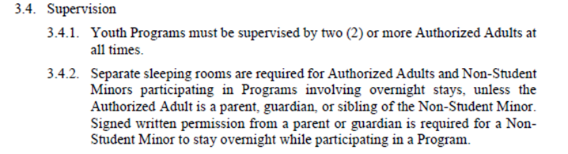

I have attached the policy document in its entirety, as there are other relevant requirements that you want to be aware of for planning activities, including obtaining signed waiver forms. These forms are available through Mines Environmental Health and Safety (EHS).

**OFF CAMPUS:**

Field trips, etc. that are part of an on-campus program will continue to be allowed and activities will be guided by SDBOR Minors on Campus Policy 1.6.4.

As for activities that support travel outside of an on-campus program: there is no SDBOR policy to cover these activities when the minor is neither a student nor an employee of the university. The single way of providing such travel support would be to also support travel for at least one of a minor’s parents or legal guardians so that they will travel with the minor. Waiver forms (available through EHS) must be signed by all persons traveling.

If you have any questions about these requirements, please contact Jerilyn Roberts.